***Problems***

***Electric Force***

1. Find the net force on charge q 1 due to the three other charges in figure. Take q1= -5μC , q2 = -8 μC, q3 = 15 μC and q4 = - 16 μC , a= 5cm. (2.3 I – 2.4j)

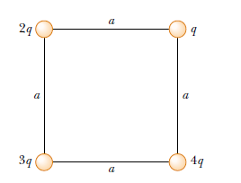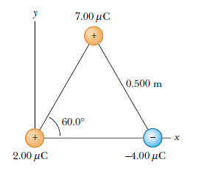

Fig-1 Fig-2

1. Three point charges are located at the corners of an equilateral triangle, as shown in Figure -2 . Calculate the net electric force on the 7 μ C charge.
2. A point charge q1 = - 9 μC is at x=0 , while q2= 4μC is at x=1 m. At what point, besides infinity, would the net force on a positive charge q3 be zero ? (d=2m)
3. The electron and the proton in a hydrogen atom are 0.53 x 10-10 m apart. Compare the electrostatic and gravitational forces between them. Fg/Fe = 4.4 x 10^-40
4. A t what separation would the force between a proton and an electron be 1 N ? (1.52 x 10^-14m)
5. A proton orbits with a speed v = 294 km /s just outside a charged sphere of radius r = 1.13cm. Find the charged sphere. ( e = 1.9 x 10-19C and m = 1.67 x 10-27) (1.13 x 10^-9)

***Electric Field***

1. On a clear day there is an electric field of approximately 100N/C directed vertically down at the earth’s surface. Compare the electrical and gravitational field on an electron.5.6
2. A point charge Q1 =20 μC is at (-d, 0)while Q2 =-10 μC is at (+d,0). Find the resultant field strength at a point with coordinates (x, y). Take d= 1m and x=y=2m.
3. Consider the electric dipole shown in Figure -3. Show that the electric field at a distant point along the x axis is : 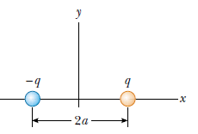Fig-3
4. What is the electric field strength needed to balanced the weight of the following particles near the Earth’s surface :(a) an electron and (b) a proton.
5. What is the magnitude of a point charge that would create an electric filed of 1 N/C at a at point 1 m away ?
6. Two particles are fixed to an x axis : particle 1 of charge -2x 10-7C at x=6cm and particle 2 of charge +2 x 10-7C at x = 21cm . Mid way between the particles, what is their net electric field in unit-vector notation?

***Gauss Law***

1. A circular plate has a radius of 12 cm. The plane of the plate is set at a 30° angle to a uniform fields E= 450N/C, as shown in figure. What is the flux through the plate.

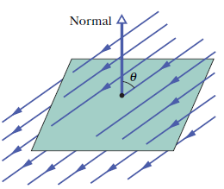

1. Two charges q1 = 6 μC and q2 = -8 μC are within a spherical surface of radius 5 cm. What is the total flux through the surface?
2. An isolated conductor of arbitrary shape carries a net charge +10 μC. Inside the conductor is a hollow cavity within which is a point charge q = +3 μC. What is the charge (a) on the cavity wall and (b) on the outer surface of the conductor?
3. A point charge of 1.8 μC is at the center of a cubical Gaussian surface 55cm on edge. What is the net flux through the surface?
4. A uniform charged conducting sphere of 1.2 m diameter has a surface charge density of 8.1 μC /m2.(a) Find the net charge on the sphere (b) what is the total electric flux leaving the surface of the sphere?
5. An infinite line of charge produces a field of 4.52 x 104 N/C at a distance of 1.96m. Calculate the linear charge density.
6. A 60 μC charge is at the center of a cube of side 10 cm .(a) what is the total flux through the cube ?(b) What is the flux through the face ? (c) would your answers to (a) or (b) change if the charge were not at the center?
7. A spherical conductor of radius 8cm has a uniform surface charge density 0.1 nC/m2. Find the electric field (a) at the surface (b) at a distance 10 cm from the center.